Discrete Control Systems
Lab Report

INTRODUCTION

Discrete control system refers to the control theory of discrete – time systems which depends on discrete variational principles. In this report, an example of Seesaw system is taken into account for understanding and developing sophisticated and complex control system. This system is divided into 8 different tasks for better understanding in this report.
OBJECTIVE- The objective of the Lab is to design and model a non-linear dynamic system, a Seesaw system in MATLAB Simulink. Linearize and make linear state space model for a working point. Develop a PI-state-feedback control based on linear model. Convert continuous system to discrete. Develop full state observer and calculate the error feedback vector. Compare and observe the change in initial conditions, reference value steps, disturbance torque in linear and nonlinear systems. The systems to be modelled is as below:
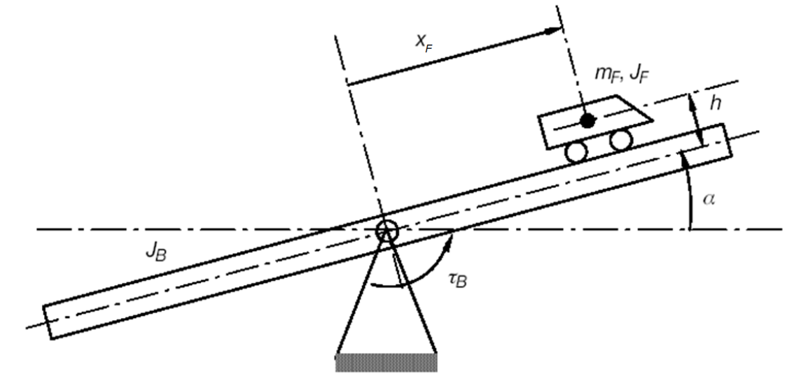

Figure 1: Seesaw System
Where,
: Drive torque of the beam tilt motor
: Position of vehicle on the beam
: Tilt angle of the beam
: Momentum of inertia of the vehicle and the beam
: Mass of the car
: Height of the vehicle above the beam middle

TASK 1

- Make a nonlinear model in MATLAB Simulink for the Seesaw System

Where,
and
Lagrange function L is:

Solving for and , we get:

The above equation completely describes the Seesaw system’s nonlinear movement.

Using these two equations the nonlinear Seesaw system can be modelled in MATLAB Simulink.

Matlab code
Jb = 0.5 %Jb=0.5kg*m^2
mf=0.1 %mf=0.1kg
h=0.1 %h=10cm
g=9.81 %g=9.81m*s^-2
Jconst=mf*h^2+Jb;
alpha=out.alpha;
alpha_dot=out.alpha_dot;
xf=out.xf;
xf_dot=out.xf_dot;

tiledlayout(2,1)

figure=nexttile;

hold on

plot (alpha_dot)
plot (alpha)
title('alpha compare')
xlabel('time in seconds')
ylabel('angle in radian')
legend('alpha','alpha dot')
hold off

figure=nexttile;

hold on

plot(xf)
plot(xf_dot)
title('xf compare')
xlabel('time in seconds')
ylabel('distance in meters')
legend('xf','xf dot')

hold off

